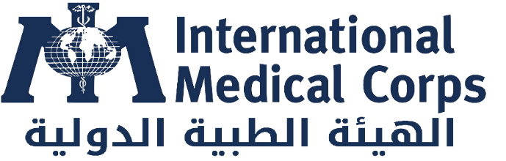

One-year Blanket Purchase Agreement for the Supply of diesel
Requirements | Yes | No | Comment
- Do you have a business certificate license?
Please refer to Annex B.
- Does your company have experience supplying diesel fuel to other organizations?
Please refer to Annex B.
- Does your company have an operating license to buy and sell petroleum products?
Please refer to Annex B.
- Does your company have a franchise agreement to buy and sell petroleum products on behalf of a licensed party?
Please refer to Annex B.
- Does your company use a bowser/fuel tank for the delivery of diesel?
Please refer to Annex B.
- What is the capacity of your bowser/fuel tank and is it fitted with at least 25 meters of hose length?
Please refer to Annex B.
- Can your company hold a minimum of 10,000 liters of diesel fuel per time?
Please refer to Annex B.
- Can your company supply diesel to the IMC office in less than 2 days after the PO/WO/Contract is signed?
Please refer to Annex B.

Financial Consideration

- Does your company have a functional bank account in Sudanese Pounds (SDG) with the Bank of Khartoum? (We require companies with a functional company bank account with the Bank of Khartoum).
The IMC reserves the right to accept or reject an award to a company not meeting this requirement.
Please refer to Annex B.
- Can your company accept at least a 30-day payment policy?
Please refer to Annex B.
- Can your company accept USD-pegged contracts but SDG payments using the Bank of Khartoum exchange rate on the date of payment?
Please refer to Annex B.

